

MODEL

SM-60.3YD, SM-60.3YH
DOUGH ROLLING MACHINE
(FLAT TRIPLE), (SPEED CONTROL TRIPLE)

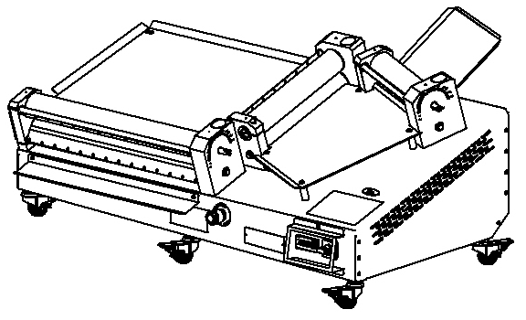

USER & MAINTENANCE MANUAL

ŞENGÜN MAKİNA İNŞAAT ve KIRTASİYE SAN. TİC. LTD. ŞTİ


WARRANTY CERTIFICATE
SERIAL NUMBER :
SALE DATE :
Sold at the above date SM– 60.3 .….. MODEL DOUGH ROLL OUT MACHINE is guaranteed against production failures for 1 Year by ŞENGÜN MAKİNA İNŞAAT ve KIRTASİYE SAN. TİC. LTD. ŞTİ.

Warranty Terms;
- Warranty terms start after the product delivery for 1 year.
- Recommended daily working time is 10 hours. The scope of warranty is assessed by year or by working hours.
- The product is under warranty except plastic rollers (included plastic rollers if it is a manufacturing defect).
- Documents are invalid, if haven’t sale date and confirm signature of company. You have to show the warranty certificate to benefit from the warranty.
- Device is guaranteed against defects if mount and use as described ın the use and maintenance manual.
- Detection the location of defects, and elimination of the problems are responsibilities of the ŞENGUN MAKİNA…
- Warranty terms include only one device. You can’t claim any rights or compensation for another device.
- If Changes are made at the type, model and serial numbers, the warranty eliminates.
- If material, worker or assembly defects appear, repaired free by ŞENGÜN MAKİNA at the product warranty period (Transportation cost is not included).
- Failures are only repaired by ŞENGÜN MAKİNA’s personal. The intervention of unauthorized person, cancel the appliance of warranty.
- Installation have to be done by ŞENGÜN MAKİNA’s personal. İf usage place changes, customer must give information to ŞENGÜN MAKİNA
- In the event of failure service must be informed.
- The failures and damages given by external factors are out of the warranty terms.
- Any failure of the product warranty period is added to the product warranty time. The repair time is until 20 working days.

AUTHORIZED PERSON
STAMP –SIGNATURE

PRESENTATION

Dear Users,
Thank you for your prefer our machine and confidence in our company. Our machines are used in 39 countries.
Our machine is manufactured according to international standards. Please read the operating manual to get the mast out of your machine. Please note the following warnings before calling our service.

ŞENGÜN MAKİNA

- Please read the manuel carefully before installing the machine.
- The machine will be out of warranty when your operate the machine with at read.
- Please read carefully the manual that gives you information on the installation is prepared in accordance with the legal regulations before arriving at the machine installation.
- For information you coonot understand, ask your nearest out horized service
- Please note that if the technical service personnel is kept waiting you will be billed for each hour.

CONTENTS
WARRANTY CERTIFICATE

PRESENTATION

SECTION 1: INTRODUCTION
1.1 General Introduction of Dough Rolling Machine Model: SM-60.3 YD, SM-60.3 YH
1.2 Technical Specifications Table
1.3 Safety Warnings Labels

SECTION 2: INTRODUCTION OF MACHINE BODY COMPONENTS

SECTION 3: INSTRUCTIONS FOR US
3.1 Usage Recommendations
3.2 Safety Warnings
3.3 Operating and Starting Instructions

SECTION 4: MAINTENANCE
4.1 Exterior Body Maintenance
4.2 Scraping Knife Maintenance

BÖLÜM 5: DOUGH ROLLING SPEED CONTROL INSTRUCTIONS FOR USE

SECTION 6: SPARE PARTS MANUAL
6.1 SM-60.3 YD Spare Parts
6.2 SM-60.3 YH Spare Parts

SECTION 7: ELECTRICAL DİAGRAM
7.1 SM-60.3 YD Electrical Diagram
7.2 SM-60.3 YH Electrical Diagram

SECTION 1: INTRODUCTION
  - General Introduction of Dough Rolling Machine Model: SM-60.3 YD, SM-60.3 YH:
Uses at lahmacun, pizza and other dough rolling processes. Dough thickness and diameter get easy with roller gap adjustment system. Dough rolling process perform in min. 12, max. 15 seconds with fast and easy using feature.

Technical Specifications Table:

Technical Specifications Table | SM-60.3YD | SM-60.3YH
Width (cm) | 76 | 76
Length (cm) | 119 | 119
Height (cm) | 62 | 62
Machine Weight (Kg) | 99,8 | 99,8
Engine Power (kW) | 1 KW | 0,80 KW
Electrical Specifications (V-HZ) | 230V 1N 50/60HZ | 230V 1N 50/60HZ
Dough Weight (gr) | 80-450 | 80-450
Dough Diameter (cm) | 26-60 | 26-60
Roller Range (mm) | 0-2 | 0-2
Hourly Production Quantity | 240-300 | 240-300

1.3 Safety Warnings Labels:
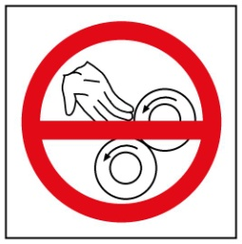
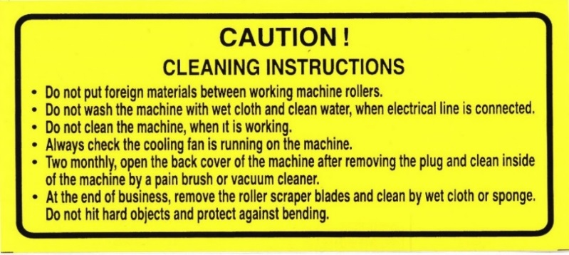

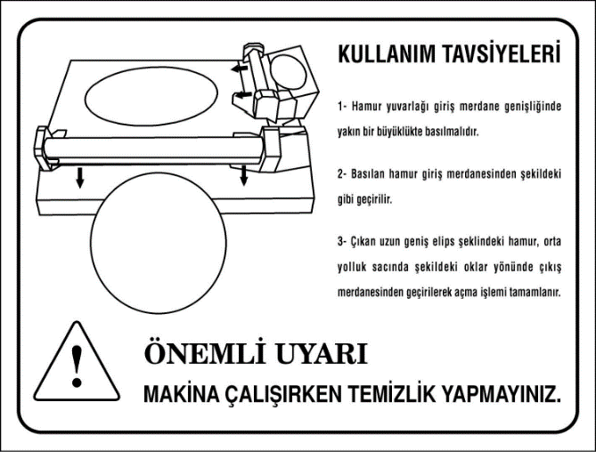
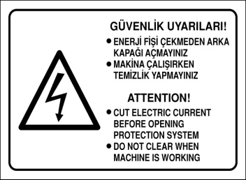

SECTION 2: INTRODUCTION OF MACHINE BODY COMPONENTS

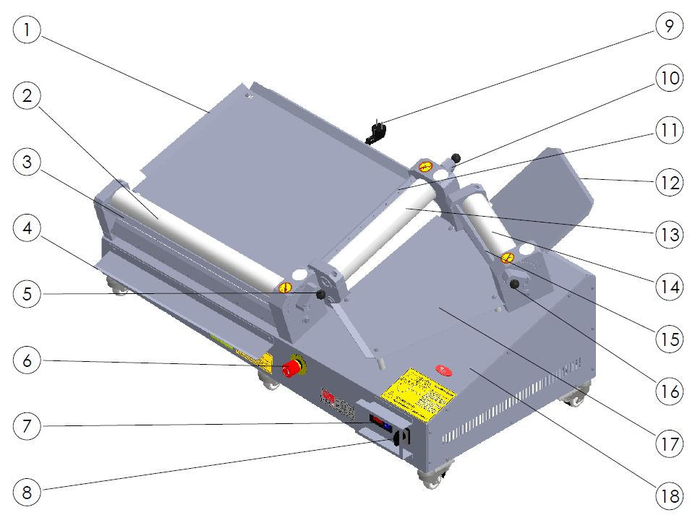

PART DESCRIPTION
1 | BOTTOM SHEET | 10 | CENTRAL ROLLER ADJUST HANDLE
2 | BOTTOM ROLLER | 11 | CENTRAL ROLLER SCRAPERS
3 | BOTTOM ROLLER SCRAPERS | 12 | ENTRANCE SHEET
4 | PRODUCT OUT SHEET | 13 | CENTRAL ROLLER
5 | BOTTOM ROLLER ADJUST LEVER | 14 | ENTRANCE ROLLER
6 | EMERGENCY STOP | 15 | ENTRANCE ROLLER SCRAPERS
7 | SPEED CONTROL UNIT | 16 | ENTRANCE ROLLER ADJUST LEVER
8 | START/STOP SWITCH | 17 | CENTRAL SHEET
9 | POWER CABLE | 18 | BODY

SECTION 3: INSTRUCTIONS FOR USE

3.1 Usage Recommendations:
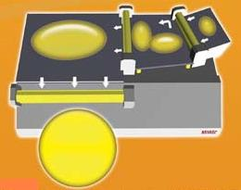

- Compress the dough and make it circular.
- Pass through the dough to the entrance roller gap shown in figure. (Adjust the dough length shown in figure.)
- Rotate the dough (shown in figure) then pass through the dough in parallel to the second roller gap.
- Pass through the ellipse shape dough to the exit roller gap shown in figure.

3.2 Safety Warnings:

- Secure voltage is between 230 V and 240 V
- Set up on a straight floor.
- Single phase on operating.
- Don’t wipe the machine with a wet cloth when connect to plug.
- Cut electric current before opening protection system.
- Check the air intake of the cooling fan daily.

3.3 Operating and Starting Instructions:

- Connect to mono phase electrical supply.
- Push the “I” button.
- Adjust the roller gap shown in picture. (This procedure adjusts the dough thickness and diameter)
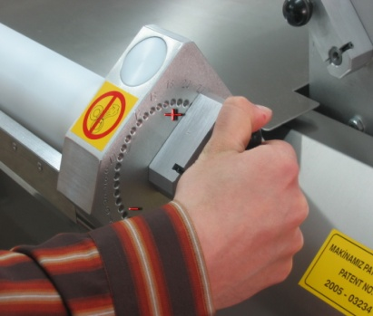
Adjust the dough thickness from “0” to “20” shown in figure.

- Pull back the bakalite knob and rotate the knob to “+” or “-” direction.
- Rotate the knob to “+” direction for enlarge the dough thickness.Rotate the knob to “-” direction for reduce the dough thickness.
- Push the bakalite knob when the intended roller gap adjusted.

NOTE = Entrance roller gap advice to be bigger than the exit roller gap.
NOTE = Scraper knifes must be stretched.

SECTION 4: MAINTENANCE
4.1 Exterior Body Maintenance:
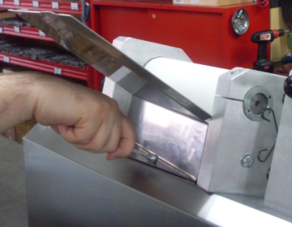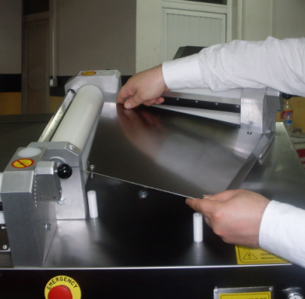
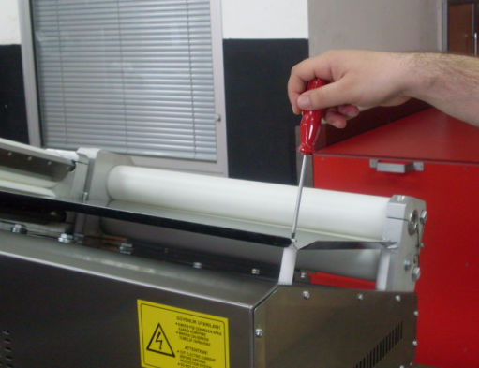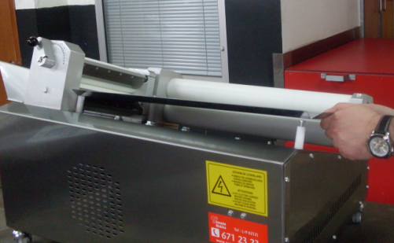
Pull up the entrance and midway plates shown in picture then clean the flour and crumbs. Stop the machine and unplug the electrical supply then clean with wet cloth. Don’t plug the electrical supply before the machine dry.
4.2 Scraping Knife Maintenance:
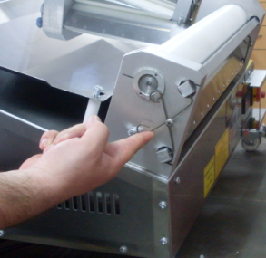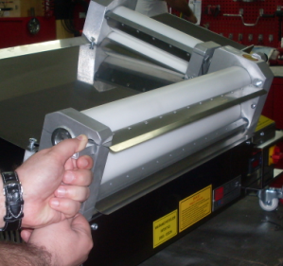
- Push up scraping knife pins shown in picture.
- Remove the scraping knifes shown in picture and clean them. Clean the scraping knifes daily.

4.3 Launder Cleaning Out Sheet:

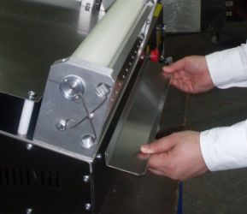
• Output can be seen in sprue plate is cleaned by removing mounting bolts are available.

SECTION 5: SM-60.3 SPARE MACHINE ON DOUGH SPEED CONTROL APPLICATION INSTRUCTIONS

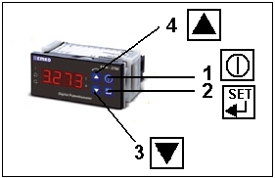

PACCO SWITCH IS OPENED AND ENERGY IS GIVEN TO THE MACHINE;
- Press the power button to start speed control.

- Press (SET) button to change roller speed with speed control. The speed value will start flashing on the screen, cycle change should be done at this time. Change the speed value with the down (3), up (4) direction buttons. Save the changed speed value by pressing (SET). (If the speed value flashes four times after pressing the SET button, the recording is done.)

- Press up (4) to turn the roller in reverse direction. When we repeat the same process, the direction of movement will return to the direction of work.

SECTION 6: SPARE PART MANUAL

6.1 SM60.3 YD Spare Part Manual:

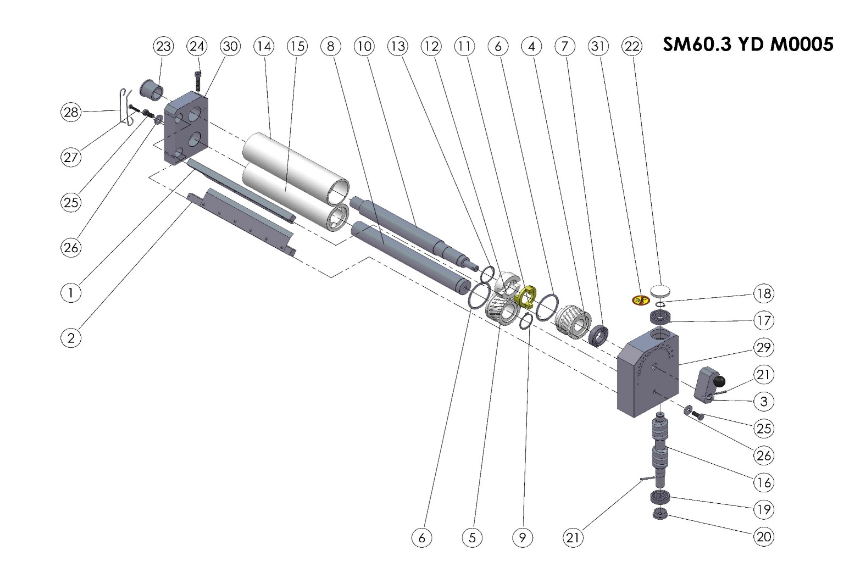
TOP ROLLER GROUP

SM60.3 YD M0005 (TOP ROLLER GROUP) FRONT SPARE PART LIST
ITEM | SPARE PART NUMBER | SPARE PART DESCRIPTION | UNIT |  | ITEM | SPARE PART NUMBER | SPARE PART DESCRIPTION |  | UNIT
1 | 00357M | ENTRANCE ROLLER SCRAPERS (TOP) | 1 |  | 17 | 00207 | BEARİNG |  | 1
2 | 00358M | ENTRANCE ROLLER SCRAPERS (LOWER) | 1 |  | 18 | 00211 | RING |  | 1
3 | 00348M | ROLLERS ADJUST HANDLE | 1 |  | 19 | 00209 | BEARİNG |  | 1
4 | 00204 | GEAR (FEMALE) | 1 |  | 20 | 00210 | THİMBLE |  | 1
5 | 00205 | GEAR (MALE) | 1 |  | 21 | 00096 | PİN |  | 2
6 | 00228 | GEAR RING | 2 |  | 22 | 00219 | COVER |  | 1
7 | 00208 | BEARİNG | 1 |  | 23 | 00222 | ECCENTRIC THİMBLE |  | 1
8 | 00244 | ENTRANCE ROLLER SHAFT (FLAT) | 1 |  | 24 | 00349 | BOLT |  | 1
9 | 00249 | RING | 1 |  | 25 | 00043 | BOLT |  | 2
10 | 00239 | ENTRANCE ROLLER SHAFT (ECCENTRIC) | 1 |  | 26 | 00044 | WASHER |  | 2
11 | 00218 | İNTERMEDİATE CLUTCH | 1 |  | 27 | 00266 | BOLT |  | 1
12 | 00227 | ROLLER İNTERMEDİATE CLUTCH | 1 |  | 28 | 00267 | SCRAPER SPRING |  | 2
13 | 00226 | O-RİNG | 1 |  | 29 | 00201 | GEAR BOX |  | 1
14 | 00260 | ENTRANCE ROLLER (TOP) | 1 |  | 30 | 00200 | ROLLER BEARİNG |  | 1
15 | 00255 | ENTRANCE ROLLER (LOWER) | 1 |  | 31 | 00037 | LABEL |  | 1
16 | 00206 | WORM | 1

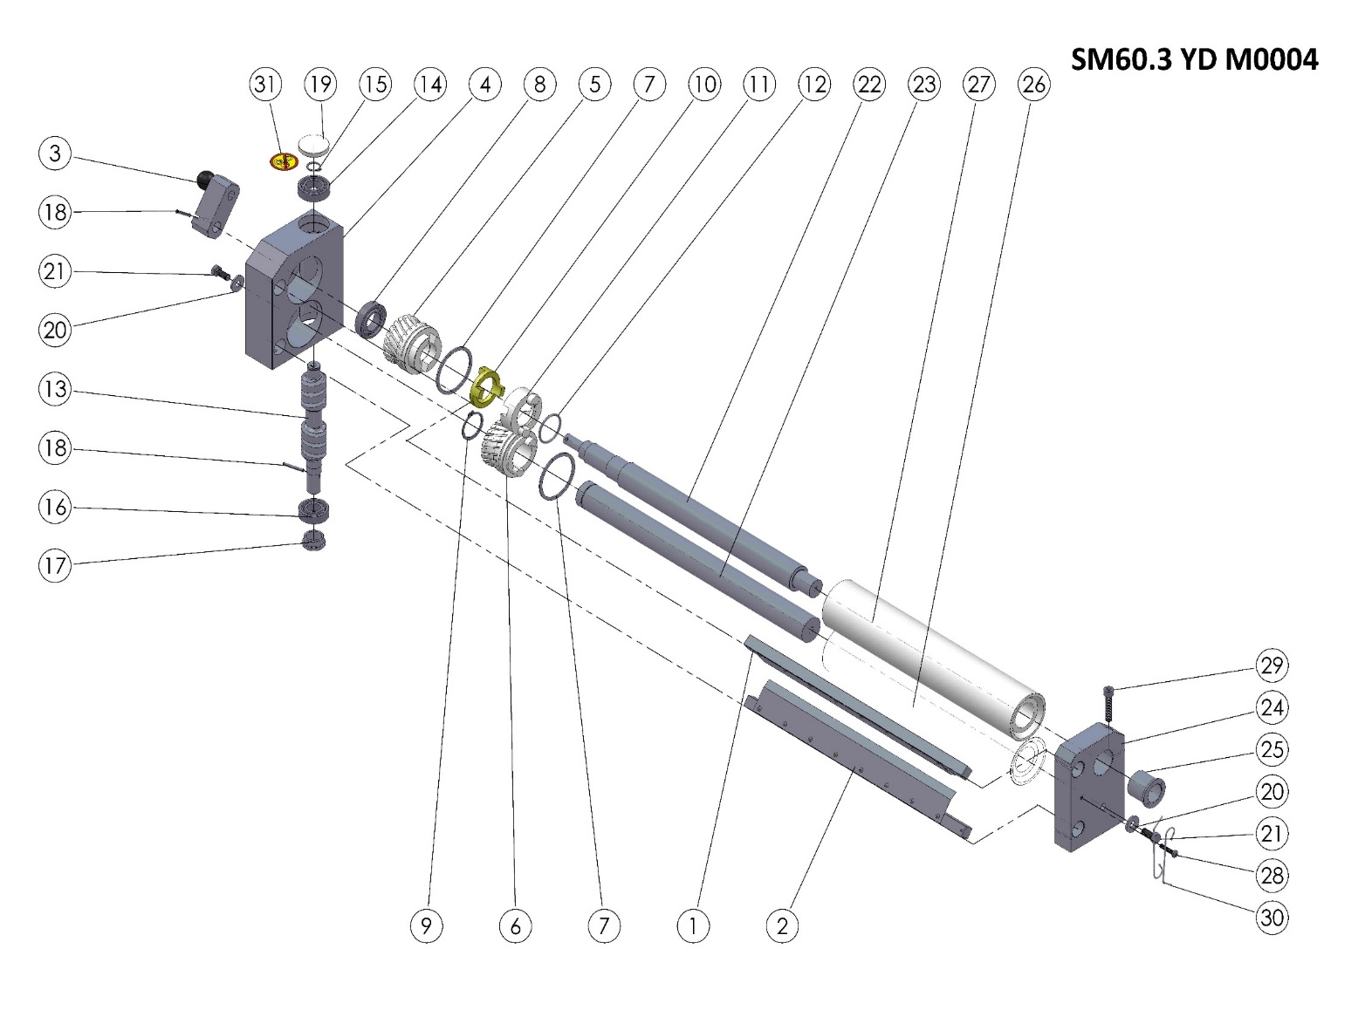
MIDDLE ROLLER GROUP

SM60.3 YD M0004 (MIDDLE ROLLER GROUP) SPARE PARTS LIST
ITEM NO. | SPARE PARTS NUMBER | SPARE PARTS DESCRIPTION | UNIT |  | ITEM NO. | SPARE PARTS | SPARE PARTS DESCRIPTION | MİKT.
1 | 00355M | CENTRAL ROLLER SCRAPER (TOP) | 1 |  | 17 | 00210 | THIMBLE | 1
2 | 00356M | CENTRAL ROLLER SCRAPERS (BOTTOM) | 1 |  | 18 | 00096 | PIN | 2
3 | 00348M | ADJUST LEVER | 1 |  | 19 | 00219 | COVER | 1
4 | 00203 | GEAR BOX REVERSE | 1 |  | 20 | 00044 | WASHER | 2
5 | 00204 | GEAR (FEMALE) | 1 |  | 21 | 00043 | BOLT | 2
6 | 00205 | GEAR (MALE) | 1 |  | 22 | 00241 | CENTRAL ROLLER SHAFT | 1
7 | 00228 | GEAR RING | 2 |  | 23 | 00246 | CENTRAL ROLLER SHAFT (STRAIGHT) | 1
8 | 00208 | BEARING | 1 |  | 24 | 00202 | ROLLER BEARING (REVERSE) | 1
9 | 00249 | RING | 1 |  | 25 | 00222 | THIMBLE | 1
10 | 00218 | CLUTCH | 1 |  | 26 | 00257 | ROLLER (BOTTOM) | 1
11 | 00227 | ROLLER CLUTCH | 1 |  | 27 | 00262 | ROLLER (TOP) | 1
12 | 00226 | O-RING | 1 |  | 28 | 00266 | BOLT | 1
13 | 00206 | WORM | 1 |  | 29 | 00349 | BOLT | 1
14 | 00207 | BEARING | 1 |  | 30 | 00267 | SCRAPERS WIRE | 2
15 | 00211 | RING | 1 |  | 31 | 00037 | LABEL | 1
16 | 00209 | BEARING | 1

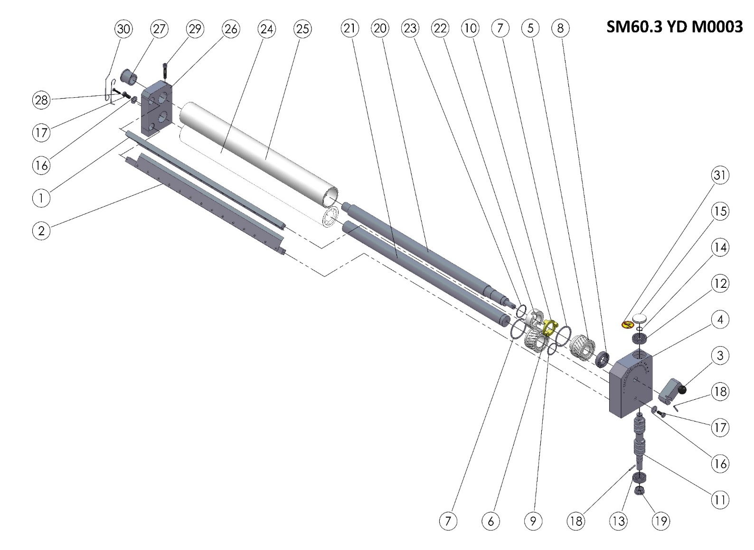
BOTTOM ROLLER GROUP

SM60.3 YD M0003 (BOTTOM ROLLER GROUP) SPARE PARTS LIST
ITEM NO. | SPARE PART NUMBER | DESCRIPTION OF THE SPARE PARTS | UNIT. |  | ITEM NO. | SPARE PART NUMBER | DESCRIPTION OF THE SPARE PARTS | UNIT.
1 | 00353M | ROLLER SCRAPER (TOP) | 1 |  | 17 | 00043 | BOLT | 2
2 | 00354M | ROLLER SCRAPER (BOTTOM) | 1 |  | 18 | 00096 | PIN | 2
3 | 00348M | ADJUST LEVER | 1 |  | 19 | 00210 | THIMBLE | 1
4 | 00201 | GEAR BOX | 1 |  | 20 | 00243 | BOTTOM ROLLER SHAFT | 1
5 | 00204 | GEAR (FEMALE) | 1 |  | 21 | 00248 | BOTTOM ROLLER SHAFT (STRAIGHT) | 1
6 | 00205 | GEAR (MALE) | 1 |  | 22 | 00227 | CLUTCH | 1
7 | 00228 | GEAR RING | 2 |  | 23 | 00226 | O-RING | 1
8 | 00208 | BEARING | 1 |  | 24 | 00259 | ROLLER (BOTTOM) | 1
9 | 00249 | RING | 1 |  | 25 | 00264 | ROLLER (TOP) | 1
10 | 00218 | CLUTCH | 1 |  | 26 | 00200 | ROLLER BEARING | 1
11 | 00206 | WORM | 1 |  | 27 | 00222 | THIMBLE | 1
12 | 00207 | BEARING | 1 |  | 28 | 00266 | BOLT | 1
13 | 00209 | BEARING | 1 |  | 29 | 00349 | BOLT | 1
14 | 00211 | RING | 1 |  | 30 | 00267 | SCRAPERS WIRE | 2
15 | 00219 | COVER | 1 |  | 31 | 00037 | LABEL | 1
16 | 00044 | WASHER | 2

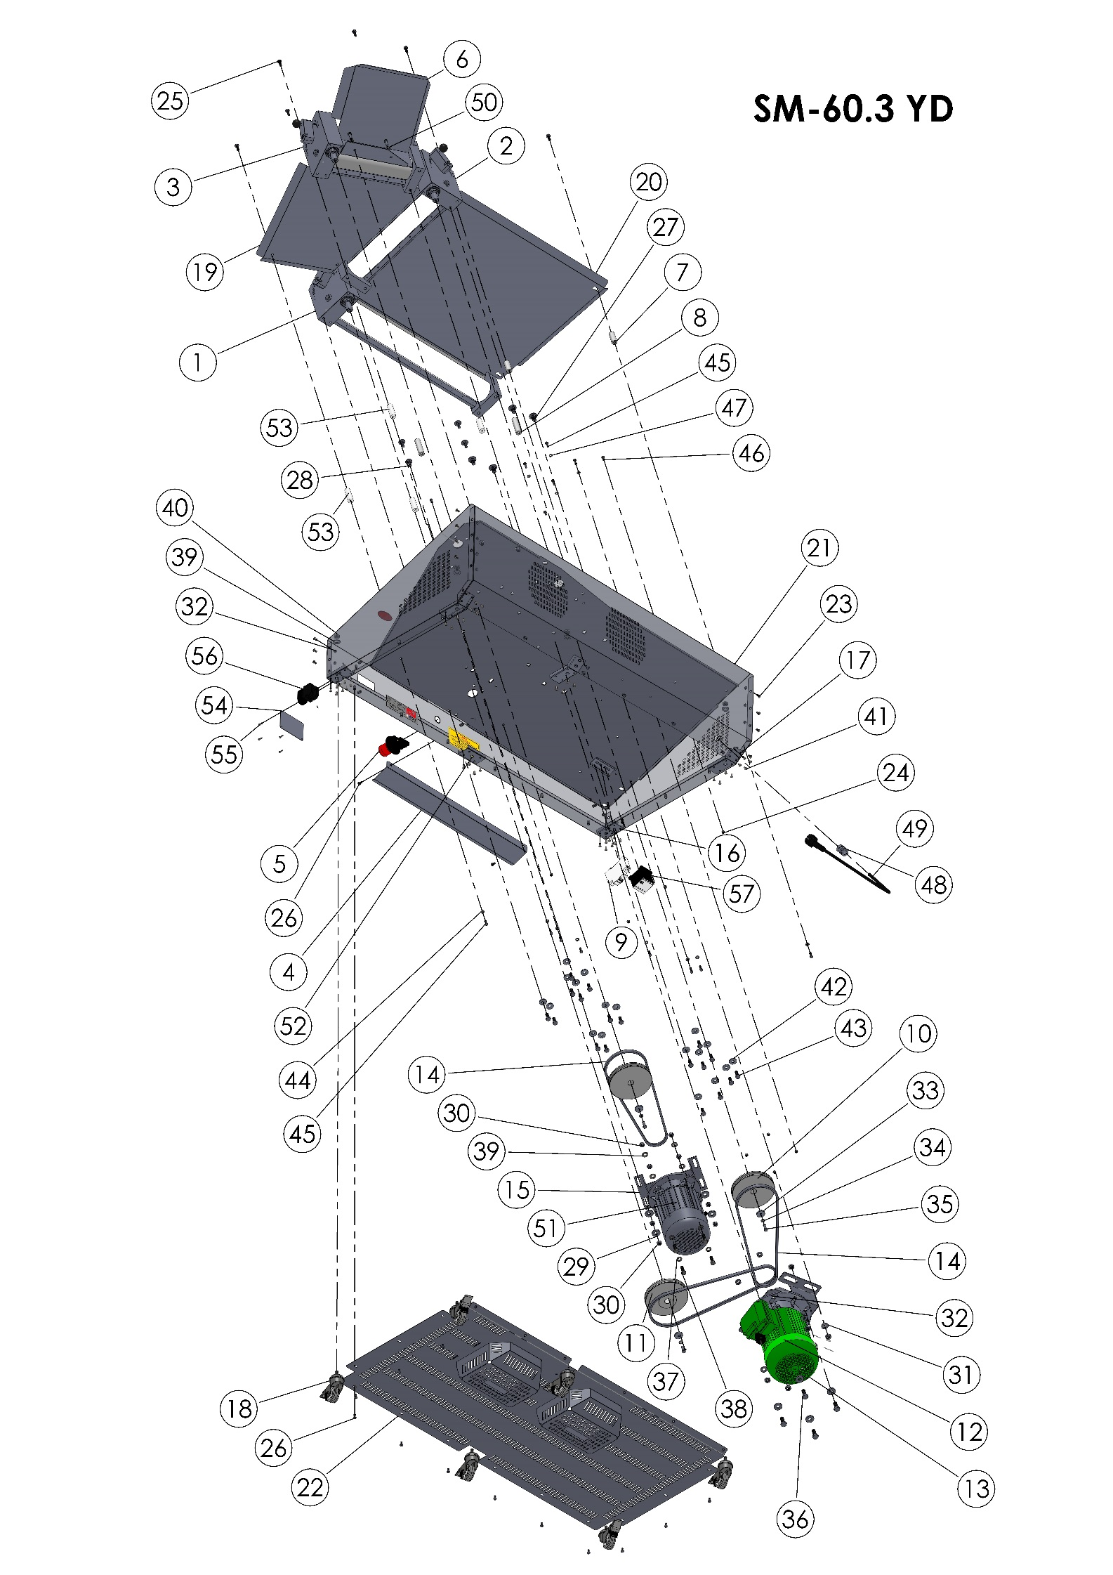

BODY

ITEM NO. | SPARE PART NUMBER | SPARE PART DESCRIPTION | UNIT. |  | ITEM NO. | SPARE PART NUMBER | SPARE PART DESCRIPTION | UNIT.
1 | SM60.3 YH M0008 | BOTTOM ROLLER GROUP(COMPLETE) | 1 |  | 32 | 00291 | BOLT | 8
2 | SM60.3 YH M0009 | MIDDLE ROLLER GROUP (COMPLETE) | 1 |  | 33 | 00278 | BOLT | 23
3 | SM60.3 YH M0010 | UPPER RPLLER GGROUP(COMPLETE) | 1 |  | 34 | 00499 | BOLT | 4
4 | 00275 | OUTPUT PLATE | 1 |  | 35 | 00476 | BOLT | 4
5 | 00314 | EMC STOP BUTTON | 1 |  | 36 | 01258 | WASHER | 4
6 | 00250 | POTENTIOMETER | 1 |  | 37 | 01959 | NUT | 8
7 | 00224 | ON/OFF SWİTCH | 1 |  | 38 | 00277 | WASHER | 14
8 | 00522 | SWITCH PROTECTION VALVE | 1 |  | 39 | 00298 | NUT | 14
9 | 00306 | UPPER FEEDER PLATE | 1 |  | 40 | 00006 | WASHER | 3
10 | 00289 | MIDDLE FEEDER PLATE PIN (SHORT) | 2 |  | 41 | 00042 | PLAIN WASHER M6 | 3
11 | 00276 | MIDDLE FEEDER PLATE PIN(LONG) | 2 |  | 42 | 00041 | BOLT | 5
12 | 00292 | LIMITER | 2 |  | 43 | 00279 | BOLT | 4
13 | 00295 | CONNECTOR | 1 |  | 44 | 01963 | WASHER | 4
14 | 00294 | CONNECTOR (BLUE) | 1 |  | 45 | 04072 | BOLT | 4
15 | 00293 | CONNECTOR (GROUNDİNG) | 1 |  | 46 | 01961 | PLAIN WASHER | 4
16 | 00301 | FUSE | 1 |  | 47 | 00205M | WHELL PLATE | 1
17 | 00213 | V BELT PULLEY | 2 |  | 48 | 01529 | RİVET | 40
18 | 00212 | PULLEY | 1 |  | 49 | 00044 | WASHER | 18
19 | 00480 | ENGINE PLATE | 1 |  | 50 | 00043 | BOLT | 18
20 | SM55 YD M0001 | ENGINE | 1 |  | 51 | 00051 | WASHER | 8
21 | 00503 | ENGINE PLATE | 1 |  | 52 | 00049 | BOLT | 12
22 | 00383 | SPEED CONTORL | 1 |  | 53 | 00048 | BOLT | 4
23 | 00528 | WHEEL PLATE | 2 |  | 54 | 02582 | WASHER | 4
24 | 00527 | WHEEL PLATE | 2 |  | 55 | 00097 | COUPLİNG | 1
25 | 00297 | WHEELS | 6 |  | 56 | 00058 | ELECTRİC CABLE | 1
26 | 00303 | MIDDLE FEEDER PLATE | 1 |  | 57 | 00317 | WASHER | 2
27 | 00309 | BOTTOM FEEDER PLATE | 1 |  | 58 | 00206M | ENGINE | 1
28 | 00203M | SM-60.3 BODY | 1 |  | 59 | 00532 | WHELLS PLATE | 1
29 | 00204M | BASE PLATE | 1 |  | 60 | 00361 | MIDDLE FEEDER PLATE PIN (SHORT)) | 4
30 | 00157 | BOLT | 14 |  | 61 | 00502 | BELT | 3
31 | 00052 | NUT | 22
SM60.3 YD BODY SPARE PARTS LIST

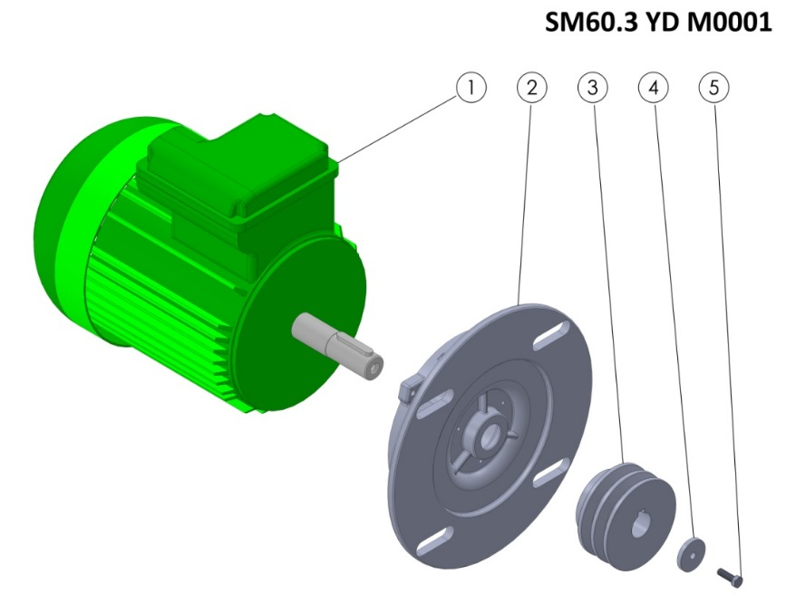
SM60.3 YD M0001 SPARE PARTS LIST
ITEM NO. | SPARE PART NUMBER | SPARE PART DESCRIPTION | UNIT
1 | 00254 | ENGINE | 1
2 | 00252 | ENGINE FLANGE | 1
3 | 00214 | V BELT PULLEY | 1
4 | 00098 | WASHER | 1
5 | 00049 | BOLT | 1

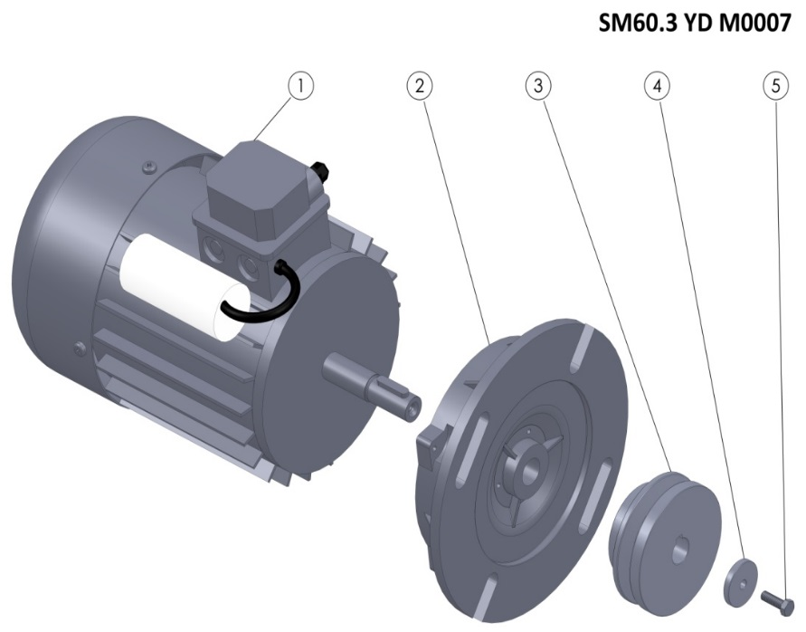
SM60.3 YD M0007 SPARE PARTS LIST
ITEM NO. | SPARE PART NUMBER | SPARE PART DESCRIPTION | UNIT
1 | 00023 | ENGINE | 1
2 | 00251 | ENGINE FLANGE | 1
3 | 00253 | PULLEY | 1
4 | 00098 | PULLEY WASHER | 1
5 | 00049 | BOLT | 1

  - SM60.3 YH Spare Parts:
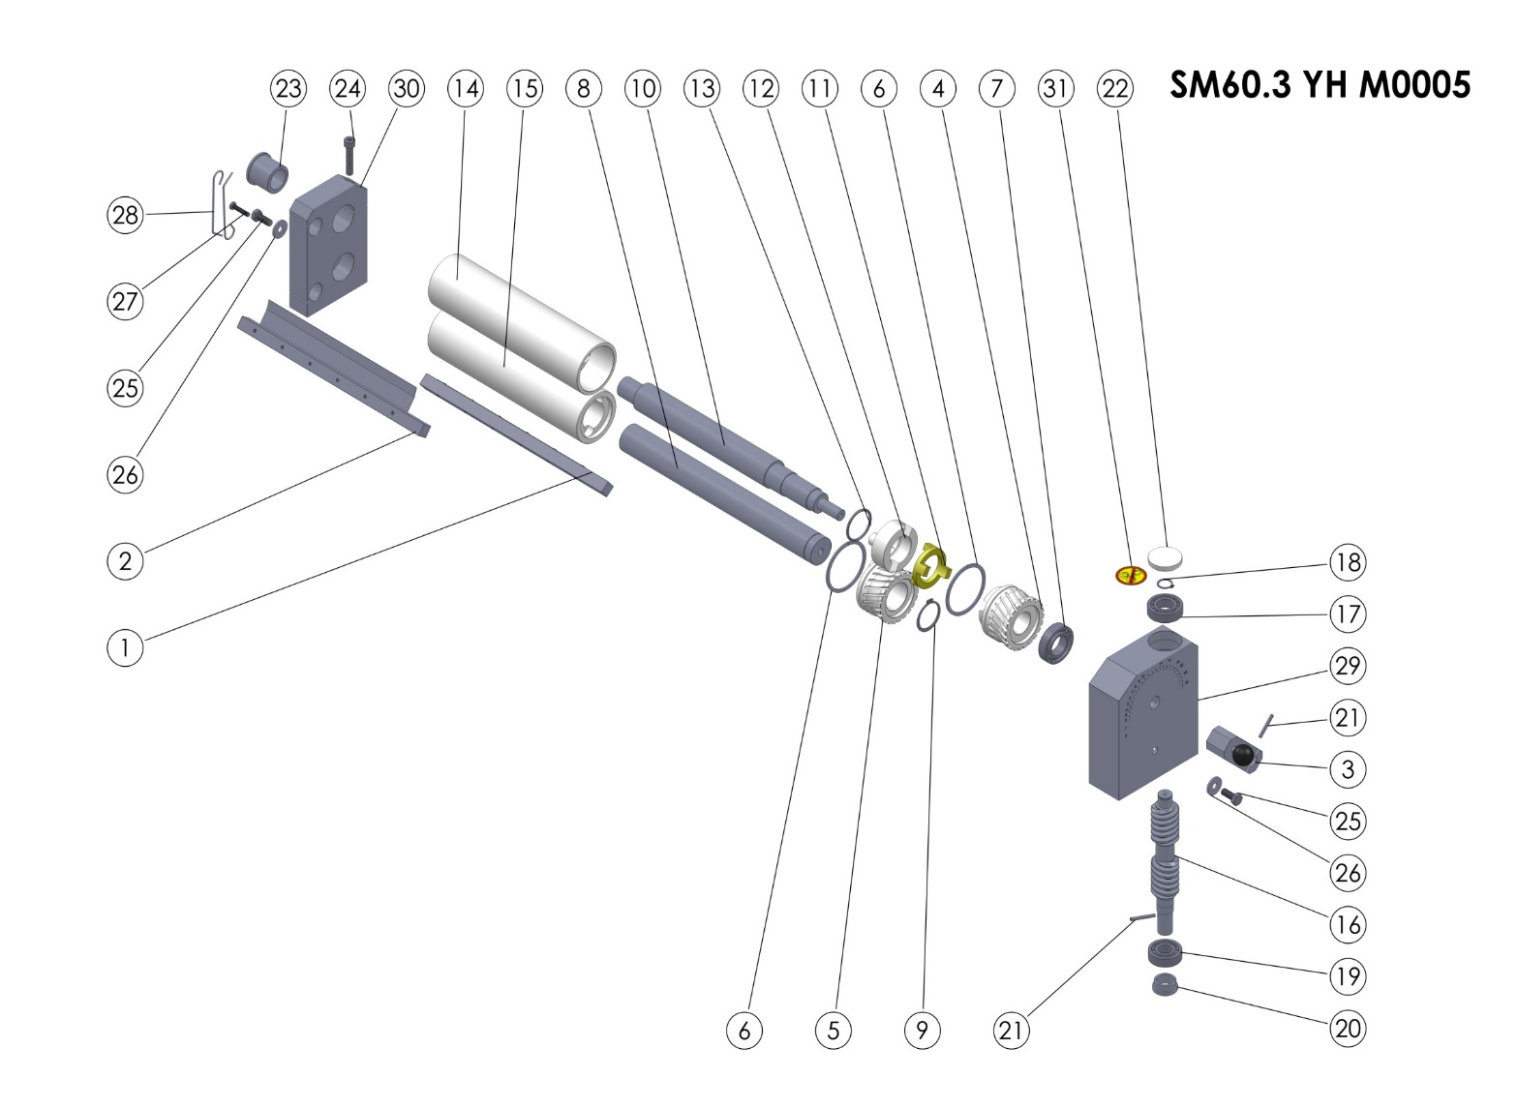
TO ROLLER GROUP

SM60.3 YH M0005 (TOP ROLLER GROUP) SPARE PARTS LIST
ITEM NO. | SPARE PART NUMBER | SPARE PART DESCRIPTION | UNIT |  | ITEM NO. | SPARE PART NUMBER | SPARE PART DESCRIPTION | UNIT
1 | 00357M | ROLLER SCRAPER (TOP) | 1 |  | 17 | 00207 | BEARING | 1
2 | 00358M | ROLLER SCRAPER (BOTTOM) | 1 |  | 18 | 00211 | RING | 1
3 | 00348M | ADJUST LEVER | 1 |  | 19 | 00209 | BEARING | 1
4 | 00204 | GEAR (FEMALE) | 1 |  | 20 | 00210 | THIMBLE | 1
5 | 00205 | GEARM (MALE) | 1 |  | 21 | 00096 | PIN | 2
6 | 00228 | GEAR RING | 2 |  | 22 | 00219 | COVER | 1
7 | 00208 | BEARING | 1 |  | 23 | 00222 | THIMBLE | 1
8 | 00244 | ROLLER SHAFT (STRAIGHT) | 1 |  | 24 | 00349 | BOLT | 1
9 | 00249 | RING | 1 |  | 25 | 00043 | BOLT | 2
10 | 00239 | ROLLER SHAFT | 1 |  | 26 | 00044 | WASHER | 2
11 | 00218 | CLUTCH | 1 |  | 27 | 00266 | BOLT | 1
12 | 00227 | ROLLER CLUTCH | 1 |  | 28 | 00267 | SCRAPERS WIRE | 2
13 | 00226 | O-RING | 1 |  | 29 | 00201 | GEAR BOX | 1
14 | 00260 | ROLLER (TOP) | 1 |  | 30 | 00200 | ROLLER BEARING | 1
15 | 00255 | ROLLER (BOTTOM) | 1 |  | 31 | 00037 | LABEL | 1
16 | 00206 | WORM | 1

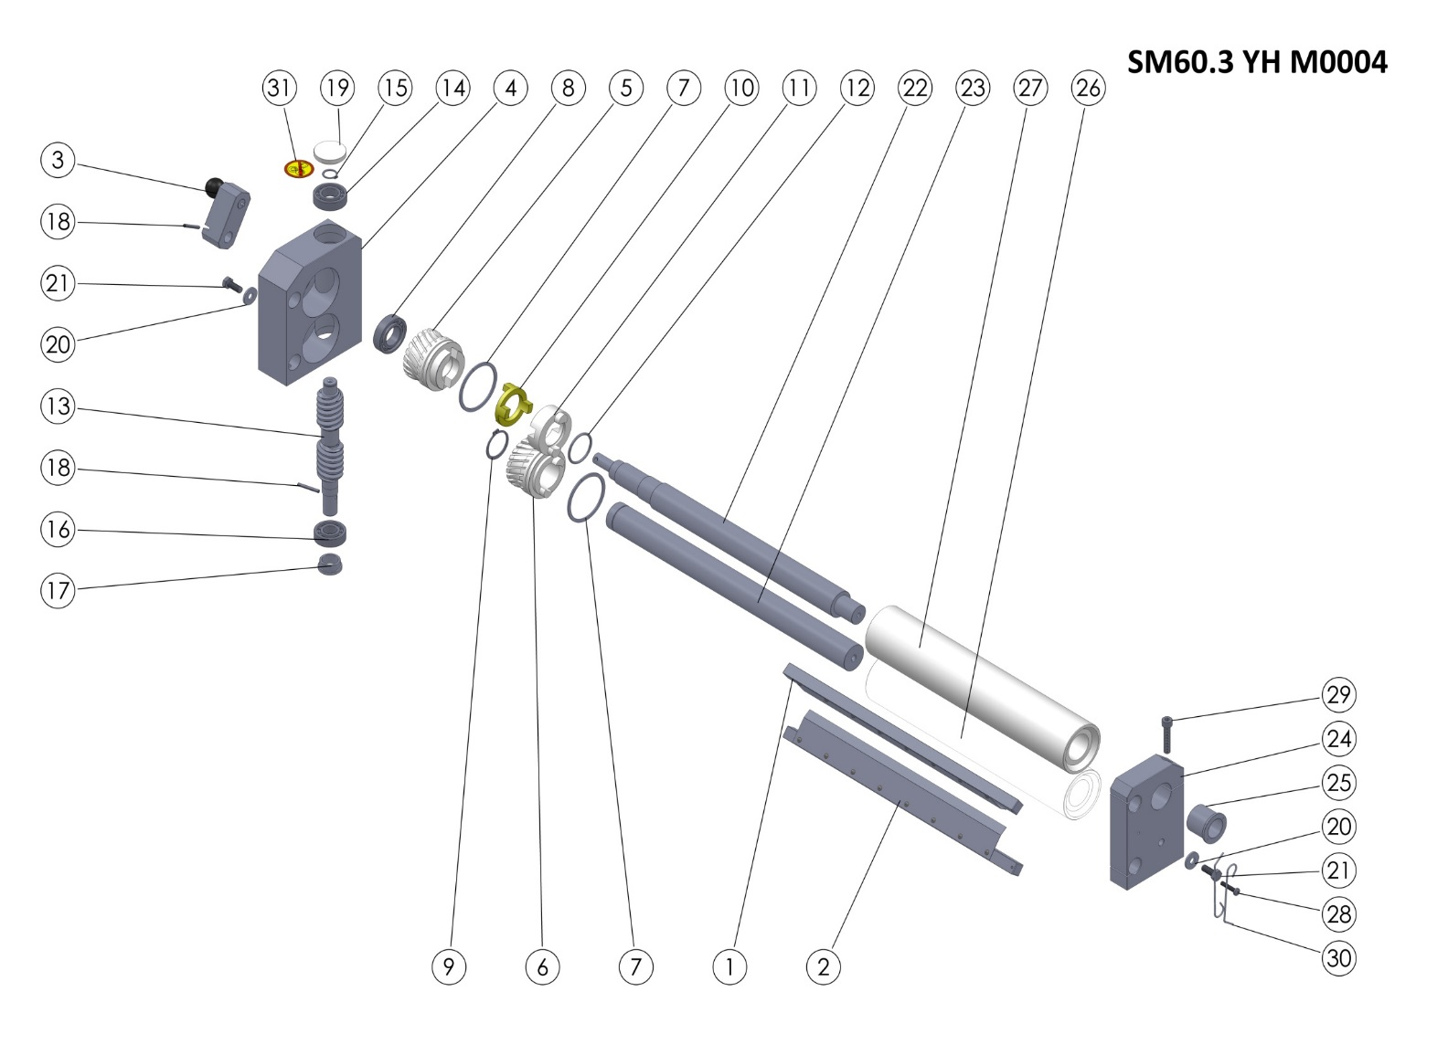
MIDDLE ROLLER GROUP

SM60.3 YH M0004 (MIDDLE ROLLER GROUP) SPARE PARTS LIST
ITEM NO. | SPARE PART NUMBER | SPARE PART DESCRIPTION | UNIT |  | ITEM NO. | SPARE PART NUMBER | SPARE PART DESCRIPTION | UNIT
1 | 00355M | ROLLER SCRAPER (TOP) | 1 |  | 17 | 00210 | THIMBLE | 1
2 | 00356M | ROLLER SCRAPER (BOTTOM) | 1 |  | 18 | 00096 | PIN | 2
3 | 00348M | ADJUST LEVER | 1 |  | 19 | 00219 | COVER | 1
4 | 00203 | GEAR BOX (REVERSE) | 1 |  | 20 | 00044 | WASHER | 2
5 | 00204 | GEAR (FEMALE) | 1 |  | 21 | 00043 | BOLT | 2
6 | 00205 | GEAR (MALE) | 1 |  | 22 | 00241 | CENTRAL ROLLER SHAFT | 1
7 | 00228 | GEAR RING | 2 |  | 23 | 00246 | CENTRAL ROLLER SHAFT (STRAIGHT) | 1
8 | 00208 | BEARING | 1 |  | 24 | 00202 | ROLLER BEARING REVERSE | 1
9 | 00249 | RING | 1 |  | 25 | 00222 | THIMBLE | 1
10 | 00218 | CLUTCH | 1 |  | 26 | 00257 | ROLLER (BOTTOM) | 1
11 | 00227 | ROLLER CLUTCH | 1 |  | 27 | 00262 | ROLLER (TOP) | 1
12 | 00226 | O-RING | 1 |  | 28 | 00266 | BOLT | 1
13 | 00206 | WORM | 1 |  | 29 | 00349 | BOLT | 1
14 | 00207 | BEARING | 1 |  | 30 | 00267 | SCRAPERS WIRE | 2
15 | 00211 | RING | 1 |  | 31 | 00037 | LABEL | 1
16 | 00209 | BEARING | 1

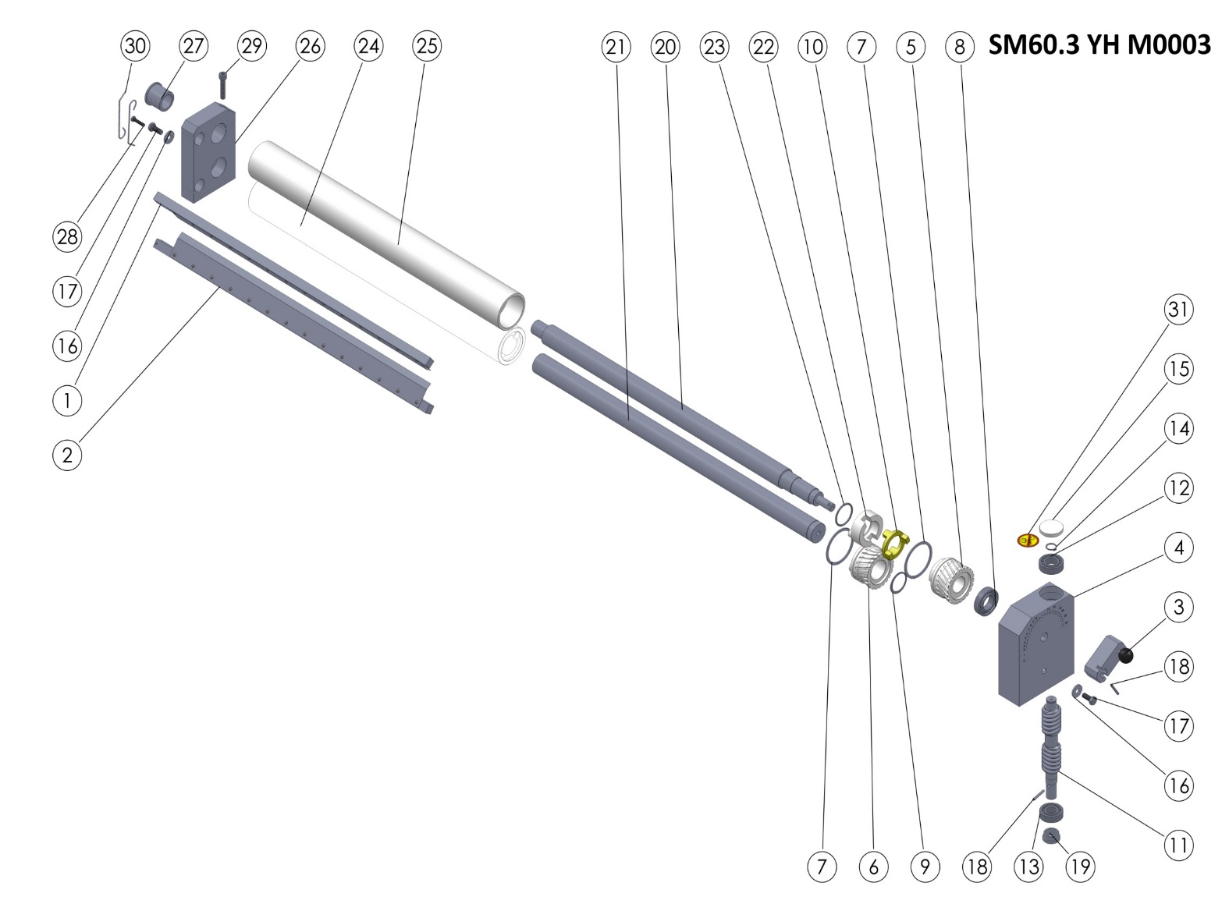

SM60.3 YH M0003 (BOTTOM ROLLER GROUP) SPARE PARTS LIST
ITEM NO. | SPARE PART NUMBER | SPARE PART DESCRIPTION | UNIT |  | ITEM NO. | SPARE PART NUMBER | SPARE PART DESCRIPTION | UNIT
1 | 00353M | ROLLER SCRAPER (TOP) | 1 |  | 17 | 00043 | BOLT | 2
2 | 00354M | ROLLER SCRAPER (BOTTOM) | 1 |  | 18 | 00096 | PIN | 2
3 | 00348M | ADJUST LEVER | 1 |  | 19 | 00210 | THIMBLE | 1
4 | 00201 | GEAR BOX | 1 |  | 20 | 00243 | BOTTOM ROLLER SHAFT | 1
5 | 00204 | GEAR (FEMALE) | 1 |  | 21 | 00248 | BOTTOM ROLLER SHAFT (STRAIGHT) | 1
6 | 00205 | GEAR (MALE) | 1 |  | 22 | 00227 | ROLLER CLUTCH | 1
7 | 00228 | GEAR RING | 2 |  | 23 | 00226 | O-RING | 1
8 | 00208 | BEARING | 1 |  | 24 | 00259 | ROLLER (BOTTOM) | 1
9 | 00249 | RING | 1 |  | 25 | 00264 | ROLLER (TOP) | 1
10 | 00218 | CLUTCH | 1 |  | 26 | 00200 | ROLLER BEARING | 1
11 | 00206 | WORM | 1 |  | 27 | 00222 | THIMBLE | 1
12 | 00207 | BEARING | 1 |  | 28 | 00266 | BOLT | 1
13 | 00209 | BEARING | 1 |  | 29 | 00349 | BOLT | 1
14 | 00211 | RING | 1 |  | 30 | 00267 | SCRAPERS WIRE | 2
15 | 00219 | COVER | 1 |  | 31 | 00037 | LABEL | 1
16 | 00044 | WASHER | 2

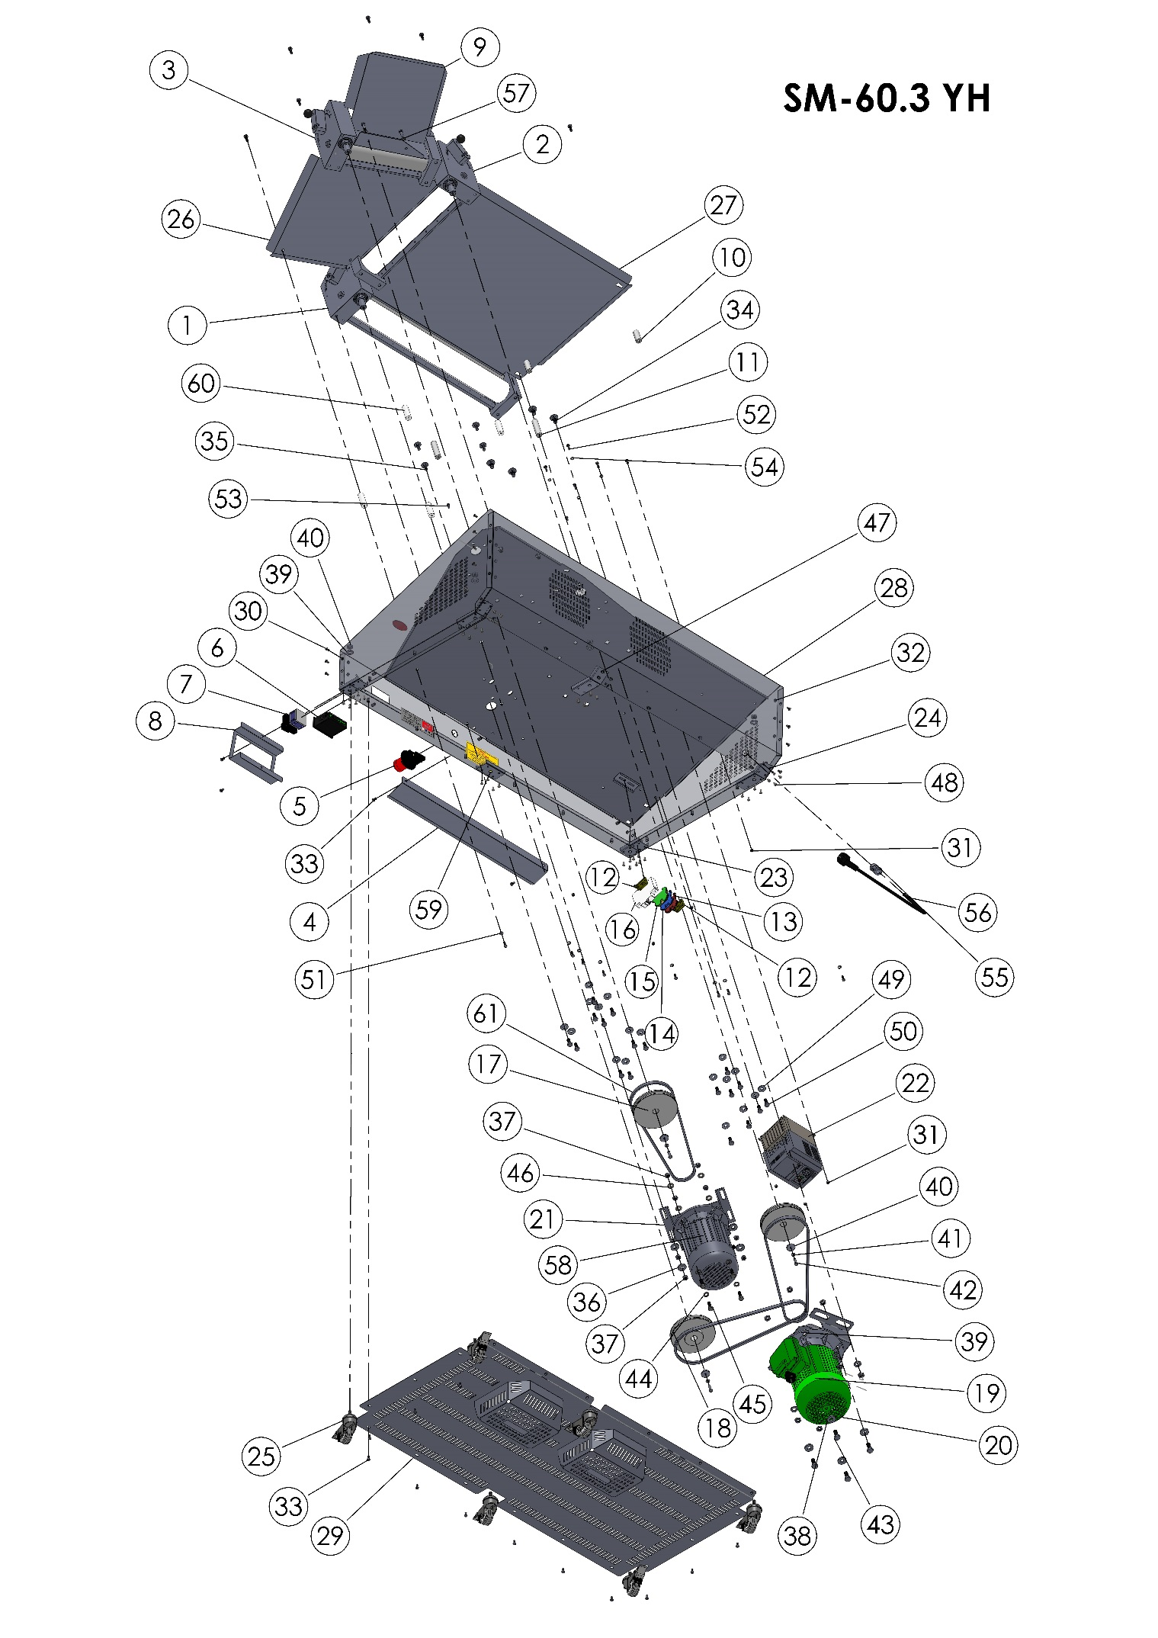

BODY

ITEM NO. | SPARE PART NUMBER | SPARE PART DESCRIPTION | UNIT. |  | ITEM NO. | SPARE PART NUMBER | SPARE PART DESCRIPTION | UNIT.
1 | SM60.3 YH M0008 | BOTTOM ROLLER GROUP(COMPLETE) | 1 |  | 32 | 00291 | BOLT | 8
2 | SM60.3 YH M0009 | MIDDLE ROLLER GROUP (COMPLETE) | 1 |  | 33 | 00278 | BOLT | 23
3 | SM60.3 YH M0010 | UPPER ROLLER GROUP (COMPLETE) | 1 |  | 34 | 00499 | BOLT | 4
4 | 00275 | OUTPUT PLATE | 1 |  | 35 | 00476 | BOLT | 4
5 | 00314 | EMS STOP BUTTON | 1 |  | 36 | 01258 | WASHER | 4
6 | 00250 | POTENTIOMETER | 1 |  | 37 | 01959 | NUT | 8
7 | 00224 | ON/OFF SWİTCH | 1 |  | 38 | 00277 | WASHER | 14
8 | 00522 | SWITCH PROTECTION VALVE | 1 |  | 39 | 00298 | NUT | 14
9 | 00306 | UPPER FEEDER PLATE | 1 |  | 40 | 00006 | WASHER | 3
10 | 00289 | UPPER FEEDER PLATE PIN (SHORT) | 2 |  | 41 | 00042 | PLAIN WASHER M6 | 3
11 | 00276 | MIDDLE FEEDER PLATE PIN  (LONG) | 2 |  | 42 | 00041 | BOLT | 5
12 | 00292 | LIMITED | 2 |  | 43 | 00279 | BOLT | 4
13 | 00295 | CONNECTOR | 1 |  | 44 | 01963 | WASHER | 4
14 | 00294 | CONNECTOR (BLUE) | 1 |  | 45 | 04072 | BOLT | 4
15 | 00293 | CONNECTOR (GROUNDİNG) | 1 |  | 46 | 01961 | PLAİN WASHER | 4
16 | 00301 | FUSE | 1 |  | 47 | 00205M | WHELL PLATE | 1
17 | 00213 | V BELT PULLEY | 2 |  | 48 | 01529 | RİVET | 40
18 | 00212 | PULLEY | 1 |  | 49 | 00044 | WASHER | 18
19 | 00480 | ENGINE PLATE | 1 |  | 50 | 00043 | BOL | 18
20 | SM55 YD M0001 | ENGINE | 1 |  | 51 | 00051 | WASHER | 8
21 | 00503 | ENGINE PLATE | 1 |  | 52 | 00049 | BOLT | 12
22 | 00383 | SPEED CONTROL | 1 |  | 53 | 00048 | BOLT | 4
23 | 00528 | WHELL PLATE | 2 |  | 54 | 02582 | WASHER | 4
24 | 00527 | WHELL PLATE | 2 |  | 55 | 00097 | COUPLİNG | 1
25 | 00297 | WHELLS | 6 |  | 56 | 00058 | ELECTRİC CABLE | 1
26 | 00303 | MIDDLE FEEDER PLATE | 1 |  | 57 | 00317 | WASHER | 2
27 | 00309 | BOTTOM FEEDER PLATE | 1 |  | 58 | 00206M | ENGINE | 1
28 | 00203M | SM-60.3 BODY | 1 |  | 59 | 00532 | WHELL PLATE | 1
29 | 00204M | BASE PLATE | 1 |  | 60 | 00361 | MIDDLE FEEDER PLATE PIN (SHORT) | 4
30 | 00157 | BOLT | 14 |  | 61 | 00502 | BELT | 3
31 | 00052 | NUT | 22
SM60.3 YH BODY SPARE PARTS LIST

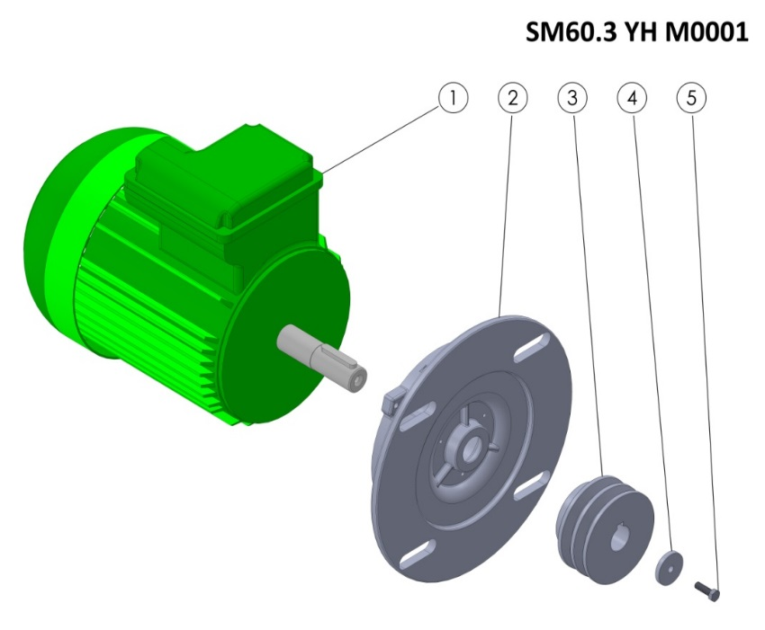
SM60.3 YH M0001 SPARE PARTS LIST
ITEM NO. | SPARE PART NUMBER | SPARE PART DESCRIPTION | UNIT.
1 | 00254 | ENGINE | 1
2 | 00252 | ENGINE FLANGE | 1
3 | 00214 | V BELT PULLEY | 1
4 | 00098 | WASHER | 1
5 | 00049 | BOLT | 1

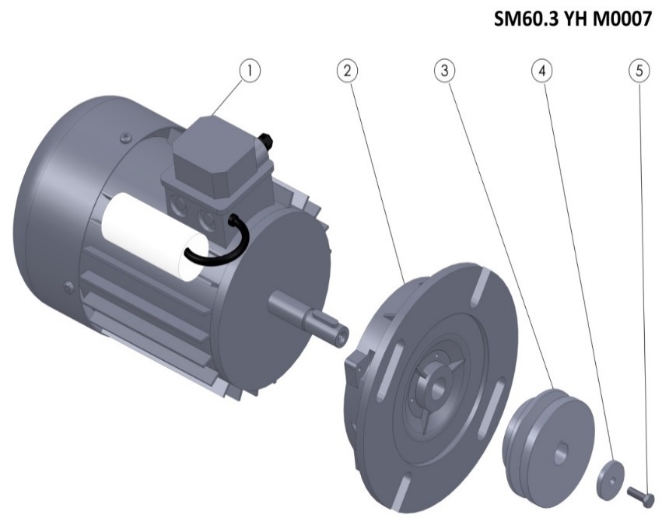

SM60.3 YH M0007 SPARE PARTS LIST
ITEM NO. | SPARE PART NUMBER |  | SPARE PART DESCRIPTION | UNIT.
1 | 00023 | ENGINE |  | 1
2 | 00251 | ENGINE FLANGE |  | 1
3 | 00253 | PULLEY |  | 1
4 | 00098 | WASHER |  | 1
5 | 00049 | BOLT |  | 1

SECTİON 7: ELECTRICAL DIAGRAM
7.1 SM60.3 YD Electrical Diagram:
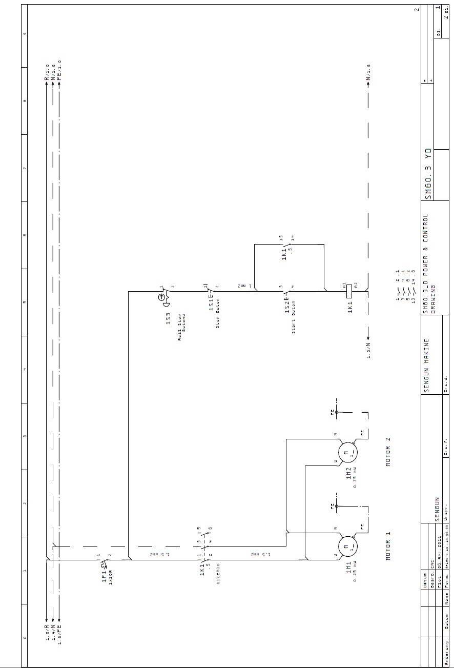

7.2 SM60.3 YH Electrical Diagram:

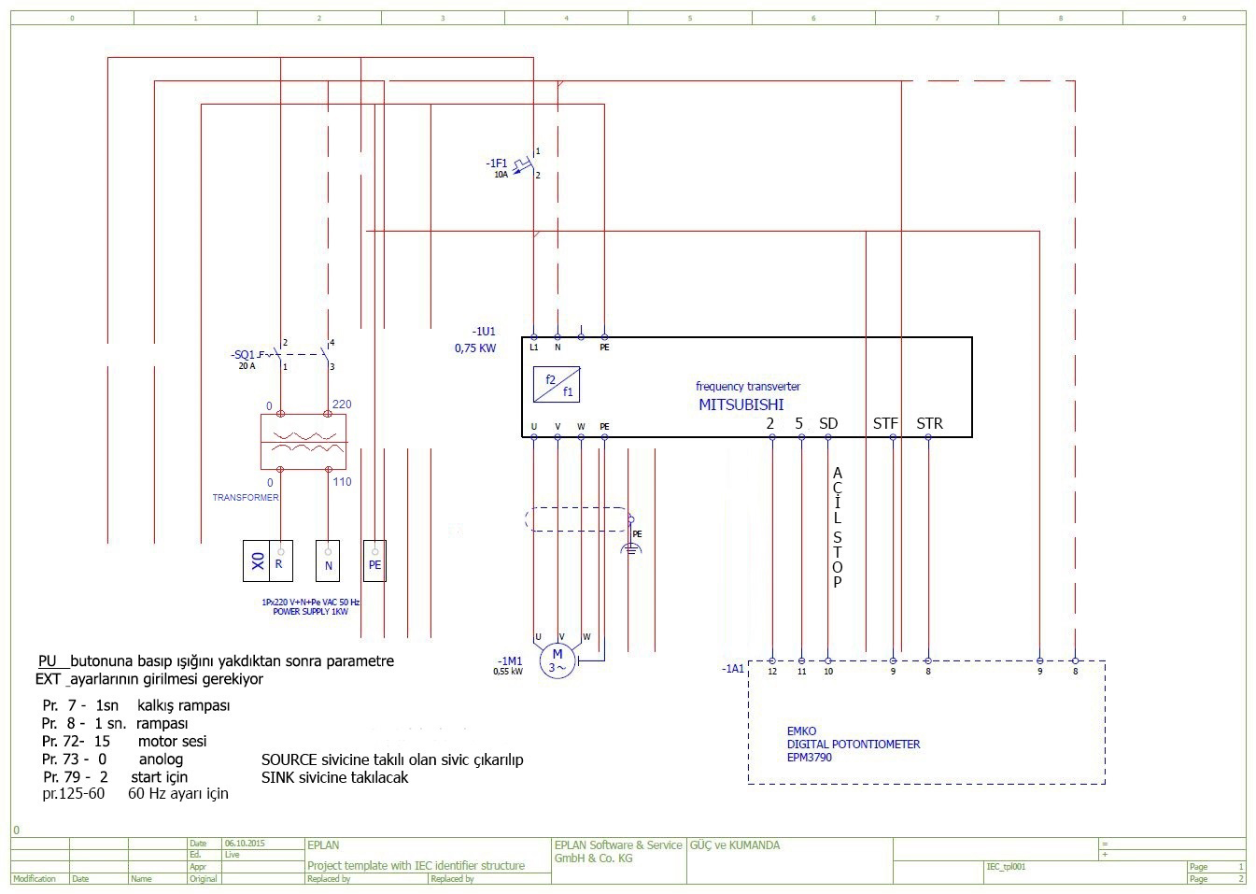

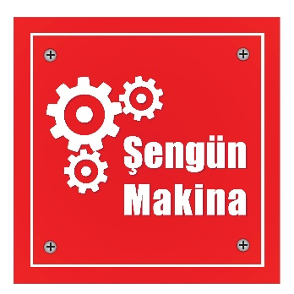

ŞENGÜN MAKİNA İNŞAAT VE KIRTASİYE SAN. TİC. LTD. ŞTİ.
İkitelli Organize Sanayi Bölgesi, Atatürk Bulvarı, Pufa İş Merkezi No: 98 Bodrum Kat: 2-3
Başakşehir/ İstanbul/ Türkiye

Phone: +90 212 671 23 23 (Pbx)
Phone 2: +90 212 671 84 84
Fax: +90 212 671 88 28
GSM: +90 533 957 14 53

e-Mail : info@sengunmakina.com
web : www.sengunmakina.com

